Prepositions:
IN: in the middle, in the centre
AT: at the top, at the bottom
ON: on the left, on the right
Learn by heart the word combinations below:
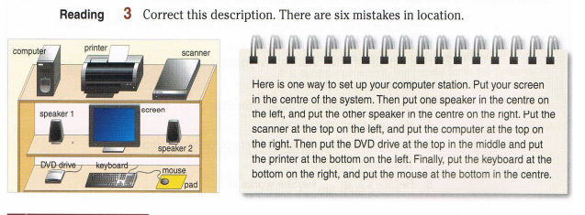

4. Look again at the computer station. Are these statements true or false? Correct the false sentences.
- The computer is at the top, on the left. T/F
- The computer is above speaker 1. T/F
- The computer is to the left of the printer. T/F

Learn by heart the word combinations below:
Prepositions:
above
below
to the to the left of
to the right of

5. Complete the sentences about the computer station in 3 with the words below.

above at below of in on to

The printer is _______ the top, _______ the middle.
The scanner is _______ the right _______ the printer.
The screen is _______ the printer.
The mouse is _______ the bottom, _______ the right.
The keyboard is _______ the left _______ the mouse.
Speaker 2 is _______ the mouse.

