Практическое занятие № 20
Тема: Материаловедение.
Повторение. Профессиональные компетенции. Термин и его перевод. Принципы работы с техническими словарями. Материалы и их свойства.
Часть 1.
Прочтите текст и выполните следующие за ним задания:
METALS
1. Mankind has used metals for centuries in gradually increasing quantities but only now they are employed in really great quantities.
2. Today we know more than seventy metals, the majority of which are used in industry.
3. Of all the metals iron is the most important one. Absolutely pure iron is never prepared except for laboratory purposes. The irons and steels in use today are really alloys of iron, carbon and other substances. They can be made elastic, tough, hard, or comparatively soft.
4. Mechanical properties of metals are the result of their atomic structure. They include hardness, ductility and malleability which are of special importance in engineering.
5. Ductility is the capacity of a metal to be permanently deformed in tension without breaking.
Malleability is the capacity of a metal to be permanently deformed by compression without rupture.
6. These properties are similar to each other but not the same. Most metals increase these properties at higher temperatures.
7. The strength of a metal is the property of resistance to external loads and stresses.
8. These mechanical properties are of great importance in industrial purposes because all parts and units made of iron and steel must meet up-to-date demands.

Задание 1. Найдите в тексте ответы на вопросы:
Вопросы
- What is the most important metal?
- What mechanical properties of metals do you know?
- What is strength?
- What is ductility?
- What is malleability?

Задание 2. Переведите на русский язык в письменной форме абзацы 3,4,5 и 7.

Задание 3. Найдите в правой колонке русские эквиваленты слов и словосочетаний:
1.lustre  2. property  3. quantity  4. conductivity  5. solid  6. brittle  7. undergo  8. to protect  9. environment  10. alloy  11. poor conductor  12. distinction  13. strength  14. hardness | a. окружающая среда  b. защищать от  c. подвергаться  d. плохой проводник  e. количество  f. блеск  g. сплав  h. свойство  i. проводимость  j. твердое состояние  k. хрупкий  l. прочность  m. жесткость  n. различие

Часть 2
Прочтите текст и выполните следующие за ним упражнения:
METALS AND NONMETALS
1. There are some distinctions between metals and nonmetal. Metals are distinguished from nonmetals by their high conductivity for electricity, by metallic lustre and by their resistance to electric current. Their use in industry is explained not only by those properties and by the fact that their properties, such as strength and hardness, can be greatly improved by alloying them with other metals.
2. There are several important groups of metals and alloys. The common metals such as iron, copper, zinc, etc. are produced in great quantities.
3. The so-called precious metals include silver, gold, platinum and palladium. The light metals are aluminium, berillium and titanium. They are important in aircraft and rocket construction.
4. Many elements are classified as semimetals (bismuth, for example) because they have much poorer conductivity than common metals.
5. Nonmetals (carbon, silicon, sulphur) in the solid state are usually brittle materials without metallic lustre and are usually poor conductors of electricity. Nonmetals show greater variety of chemical properties than common metals do.
6. Metals can undergo corrosion, changing in this case their chemical and electromechanical properties. In order to protect metals from corrosion the products made of metals and steel are coated by some films (coatings). Organic coatings protect metals and steel from corrosion by forming a corrosion-resistant barrier between metal or steel and the corrosive environment.

Задание 1. Найдите в тексте ответы на вопросы:
Вопросы
- By what properties are metals distinguished from nonmetals?
- What common metals are produced in great quantities?
- What metals are called light?
- What properties do nonmetals have?
- What is done to protect metals from corrosion?

Задание 2. Закончите предложения, найдя соответствующий вариант окончания в тексте
- There are some different groups of metals, such as:
- Light metals …
- Common metals: …
- Precious metals: ...
- Nonmetals are…

Практическое занятие № 21
Тема: Материаловедение.
Многокомпонентные термины.
Конструкционные материалы.

Material types
A. Metals and non-metals
Engineering materials can be divided into:
• metals- examples of metallic materials are iron (Fe) and copper (Cu)
• non-metals- examples of non-metallic materials are carbon (C) and silicon (Si).
As iron is such a widely used material, metals can be divided into:
• ferrous metals- those that contain iron
• non-ferrous metals- those that do not contain iron.

Задание 1. Заполните пропуски словами в рамке, используя текст A
metal / non-metal / metallic / non-metallic / ferrous / non-ferrous

- Carbon (C) is a ................................ .
- Copper (Cu) is a ................................ metal.
- Aluminium (AI) is a common ................................ .
- Steel (Fe + C) is a widely used ................................ metal.
- Although it is used in steel, carbon is ................................ .
- Aluminium is relatively lightweight for a ................................ material.

B. Elements, compounds and mixtures
With regard to the chemical composition of materials -the chemicals they contain, and how
those chemicals are combined- three main categories can be used:
• Elements are pure materials in their most basic form. They cannot be broken down into different constituents ('ingredients'). Examples of elements widely used in engineering materials are iron, carbon and aluminium (AI).
• Compounds consist of two or more elements that are chemically bound - that is, combined by a chemical reaction. An everyday example is water, which is a compound of hydrogen (H) and oxygen (0).
• Mixtures consist of two or more elements or compounds which are mixed together, but which are not chemically bound. In engineering, common examples are alloys -that is, metals which have other metals and/or non-metals mixed with them. A common example is steel, which is an iron-carbon alloy, and can include other alloying metals- metals which are added to alloys, in small quantities relative to the main metal. Examples of widely used alloying metals are chromium (Cr), manganese (Mn) and tungsten (W).

Задание 2. Прочитайте текст B и напишите, верны данные ниже высказывания или нет (True or False). Исправьте неверные утверждения
- The elements that make up a compound are chemically bound.
- Alloys are chemical compounds that are frequently used in engineering.
- Alloys can contain both metallic and non-metallic constituents.
- In an alloy, an alloying metal is the biggest constituent, by percentage.
- Steel is a metallic element.

С. Composite materials
The article below is from an engineering journal.
When you think of examples of hi-tech materials, composite materials come to mind- such as carbon-fibre, used in aerospace and Formula 1 cars.
But although we think of composites as hi-tech and highly expensive, that's not always true. The earliest examples of composite materials were bricks made from mud and straw. Or, to use the correct composite terms, from straw reinforcement- the structural network that reinforces the material inside, and a mud matrix- the material surrounding the reinforcement. These terms explain what a composite material is: it is a matrix with a reinforcing material inside it. A modern, everyday example is fiberglass - correctly called glass reinforced plastic (GRP) -which has a plastic matrix reinforced with glass fibres.

Задание 3. Прочитайте текст С. и ответьте на вопросы:
- What hi-tech material is used in aerospace and Formula 1 cars?
- What is a composite material?
- What is a modern everyday example of a composite material?

Задание 4. Используя тексты А, В, С, заполните таблицу и напишите по 2 слова в каждую колонку и добавьте 3 собственных термина в каждый столбик.

Element | Compound | Alloy | Composite

Практическое занятие № 22
Тема: Материаловедение. Инструментальные материалы.
Согласование времен. Косвенная речь
STEEL
The most important metal in industry is iron and its alloy — steel. Steel is an alloy of iron and carbon. It is strong and stiff, but corrodes easily through rusting, although stainless and other special steels resist corrosion.
The amount of carbon in a steel influences its properties considerably. Steels of low carbon content (mild steels) are quite ductile and are used in the manufacture of sheet iron, wire, and pipes. Medium-carbon steels containing from 0.2 to 0.4 per cent carbon are tougher and stronger and are used as structural steels. Both mild and medium-carbon steels are suitable for forging and welding. High-carbon steels contain from 0.4 to 1.5 per cent carbon, are hard and brittle and are used in cutting tools, surgical instruments, razor blades and springs.
Tool steel, also called silver steel, contains about 1 per cent carbon and is strengthened and toughened by quenching and tempering.
The inclusion of other elements affects the properties of the steel. Manganese gives extra strength and toughness. Steel containing 4 per cent silicon is used for transformer cores or electromagnets because it has large grains acting like small magnets. The addition of chromium gives extra strength and corrosion resistance, so we can get rust-proof steels. Heating in the presence of carbon or nitrogen-rich materials is used to form a hard surface on steel (case-hardening). High-speed steels, which are extremely important in machine-tools, contain chromium and tungsten plus smaller amounts of vanadium, molybdenum and other metals.

Задание 1. Ответьте на вопросы по тексту
- What is steel?
- What are the main properties of steel?
- What are the drawbacks of steel?
- What kinds of steel do you know? Where are they used?
- What gives the addition of manganese, silicon and chromium to steel?
- What can be made of mild steels (medium-carbon steels, high-carbon steels)?
- What kind of steels can be forged and welded?
- How can we get rust-proof (stainless) steel?
- What is used to form a hard surface on steel?
- What are high-speed steels alloyed with?

Задание 2. Найдите в тексте перевод слов и словосочетаний
- сплав железа и углерода
- прочный и жесткий
- легко коррозирует
- нержавеющая сталь
- низкое содержание углерода
- ковкость
- листовое железо, проволока, трубы
- конструкционные стали
- пригодны для ковки и сварки
- твердый и хрупкий
- режущие инструменты
- хирургические инструменты
- инструментальная сталь 14.упрочнять
- добавление марганца (кремния, хрома, вольфрама, молибдена, ванадия)

Задание 3. Прочитайте текст и напишите, верны ли утверждения после текста (Т) или нет (F). Исправьте неверные утверждения.
The second main category of steel is alloy steels, which consist of iron, carbon and one or more alloying metals. Specific grades of alloy steel include:
• low alloy steels, which contain 90% or more iron, and up to approximately 10% of alloying metals such as chromium, nickel, manganese, molybdenum and vanadium
• high strength low alloy steels (HSLA), which contain smaller quantities of the above metals (typically less than 2%)
• stainless steels, which contain chromium as well as other metals - such as nickel - and which do not rust.
• tool steels, which are extremely hard, and are used in cutting tools. They contain tungsten and/or cobalt. A widely used grade of tool steel is high-speed steel, which is used in cutting tools that operate at high temperatures, such as drill bits.

- Steel is an alloy of iron and carbon.
- Alloy steels contain carbon.
- Chromium and nickel are used as alloying metals in steel.
- Low alloy steels contain more chromium than iron.
- Stainless steel is an alloy steel.
- Tungsten is added to steel to make it softer.
- High-speed steel is suitable for making cutting tools that get very hot.

Практическое занятие № 23
Тема: Промышленное оборудование. Машины и операции в промышленности. Условные предложения. Сослагательное наклонение
Прочтите текст и выполните задания после текста:
MACHINE-TOOLS AND PROCESSES
Machine-tools are used to shape metals and other materials. The material to be shaped is called the workpiece. Most machine-tools are now electrically driven. Machine-tools with electrical drive are faster and more accurate than hand tools: they were an important element in the development of mass-production processes, as they allowed individual parts to be made in large numbers so as to be interchangeable.
All machine-tools have facilities for holding both the workpiece and the tool, and for accurately controlling the movement of the cutting tool relative to the workpiece. Most machining operations generate large amounts of heat, and use cooling fluids (usually a mixture of water and oils) for cooling and lubrication.
Machine-tools usually work materials mechanically but other machining methods have been developed lately. They include chemical machining, spark erosion to machine very hard materials to any shape by means of a continuous high-voltage spark (discharge) between an electrode and a workpiece. Other machining methods include drilling using ultrasound, and cutting by means of a laser beam. Numerical control of machine-tools and flexible manufacturing systems have made it possible for complete systems of machine-tools to be used flexibly for the manufacture of a range of products.

Задание 1. Закончите предложения, выбрав соответствующие варианты
- Machine-tools are…
А) now electrically driven
В) an important element
С) used to shape metals and other materials
- The material to be shaped is…
А) allowed individual parts
В)called theworkpiece
С) usually work materials mechanically
- Other machining methods include…
А) drilling using ultrasound, and cutting by means of a laser beam.
В) chemical machining, spark erosion to machine very hard materials to any shape by means of a continuous high-voltage
С) facilities for holding both the workpiece

Задание 2. Найдите в правой колонке русские эквиваленты английских слов
- electrically driven
- The material to be shaped
- high-voltagespark
- moreaccurate
- of mass-production processes

- обрабатываемый материал
- более точный
- электропривод
- процесс массового производства
- высоковольтный разряд

Задание 3. Переведите текст на русский язык.

Практическое занятие № 24
Тема: Промышленное оборудование. Аспекты использования компьютерных технологий. Назначение компьютера. Назначение компьютерных сетей, сервера. Трудности перевода грамматических структур: Причастия.
Задание 1. Найдите в правой колонке русские эквиваленты слов и словосочетаний:

- non-ferrous metal  - turning mill  - roughing operations  - finishing operations  - turret head  - side head  - facing  - drilling  - high rigidity  - gearbox  - multidisk friction clutch  - work feed  - table speed  - cross-rail  - V-belt | - зубчатая передача  - многодисковая фрикционная муфта  - скорость движения стола  - черновая обточка  - токарный станок  - высокая жесткость  - чистовая обточка  - торцевое точение  - револьверная головка  - боковой суппорт  - сверление  - клинообразный ремень  - цветные металлы (не железистые)  - поперечина (траверса)  - подача заготовки

Прочитайте текст и выполните следующие за ним упражнения:

VERTICAL TURNING MILLS
1. The single-column vertical turning mills are universal high-speed machines. They are designed for roughing and finishing operations on parts made of steel, non-ferrous metals.
2. The machines are provided with two heads: vertical turret head and horizontal head. Vertical turret head travels along the horizontal ways of the cross-rail. Horizontal side head moves along the vertical ways of the column.
3. The machine performs the following operations: cylindrical turning, facing, cutting, drilling, etc.
4. High rigidity of machines and their units as well as the wide range of table speeds and work feeds allow machining at most favorable cutting speeds and work feeds.
5. Motion to the table is transmitted from the main drive electric motor by means of V-belts and gearbox.
6. For starting and stopping the table rotation the gearbox is provided with multidisk friction clutch.

Задание 2. Переведите на русский язык в письменной форме абзацы 1,2 и3.
Задание 3. Найдите соответствующие ответы на вопросы в тексте
Вопросы
- What are the single-column vertical turning mills designed for?
- What mechanisms are the machines provided with?
- What operations does the machine perform?
- By what means is motion to the table transmitted?
- What mechanism is the gearbox provided with?

Задание 4. Закончите предложения, выбрав соответствующий вариант окончания:
- Vertical turret head travels along....
a) the horizontal ways of the cross-rail b) the vertical ways of the column
- Horizontal side head travels along....
a) the horizontal ways of the cross-rail b) the vertical ways of the column.
- Motion to the table is transmitted by ....
a) cross-rail b) V-belts and gearbox
- This machine is called....
a) vertical turret head b) vertical turning mill.

Задание 5. Найдите в правой колонке русские эквиваленты слов и словосочетаний:
- engine lathe a. задняя бабка
- turning b. фартук (суппорта)
- drilling c. каретка
- screw cutting d. передняя бабка
- headstock e. сверление
- tailstock f. токарно-винторезный станок
- saddle g. нарезание винтов
- lever h. рычаг
- apron i. рукоятка
- carriage j. суппорт
- guideways k. обточка
- handle l. направляющие (станка)

Прочтите текст и выполните следующие за ним упражнения:
ENGINE LATHE
1. The engine lathe is the most commonly used machine-tool. It is used in a great variety of metal operations, such as turning, drilling, screw cutting and many others.
2. The principal units of the lathe are the bed, the headstock, the tailstock and the carriage with the apron
3. The bed is the base of any machine-tool and it is made of grey iron on which the saddle and the tailstock slide along special guideways. The headstock is also located and bolted on the bed.
4. The headstock contains the spindle and the speed gearbox. The spindle is the part of the machine to which power is applied to rotate the work. The changing of the spindle speed is affected by levers.
5. The tailstock consists of a casting fitted to the bed. The function of the tailstock is to support one end of the work turned between centres and to mount the tools.
6. The carriage of the lathe, which carries the tool, is made up of two principal parts: the saddle and the apron. The saddle travels along the guideways of the bed. The apron represents the front wall of the carnage. On the front of the apron are mounted the handles and levers by which the actions of the tool are controlled.

Задание 6. Переведите на русский язык в письменной форме абзацы 3,4 и 5.
Задание 7. Найдите соответствующие ответы на вопросы в тексте
Вопросы
- What operations is the engine lathe used for?
- What are the principal units of the lathe?
- What units are located on the bed?
- What is the function of the tailstock?
- Where are the handles and levers mounted?
Задание 8. Закончите предложения, выбрав соответствующий вариант окончания:
- The unit that contains the spindle and the gearbox is …
- The unit that supports one end of the work turned between centres is called....
- The unit which carries the tool is called ....
- the carriage;
- the headstock
- the tailstock
- The unit on saddle and the is called …
- the carriage
- the bed;
- the headstock
- The units, actions of the tool are controlled, are called....
- guideways;
- the saddle and the apron;
- levers and handles.

Практическое занятие № 25
Тема: Детали и инструменты. Инструменты, детали и операции. Интернациональные слова. Трудности перевода: Независимый причастный оборот.
Прочитайте текст и выполните задание после него.
3D component features
A. 3D forms of edges and joints
The plan and sections below show the end of a stainless steel pipe and an access plate, which are part of a production line at a chemicals manufacturing plant. The top edge of the plate is chamfered- at an angle of 45 degrees with the sides of the plate. All the other edges are square (90 degrees). Around the bottom of the plate is a rebate – an internal corner. The top of the pipe is also rebated around the inside, so that the bottom of the plate can slot into the top of the pipe. In the rebate on the pipe, there is a ridge - a long, thin, raised surface. On the plate, a groove or channel is cut into the metal. The ridge on the pipe slots into this groove to form
a tongue and- groove joint (the ridge is the tongue). When the two are slotted together there is a cavity or void (a hollow space) between the top of the tongue and the end of the groove. This is to accommodate (provide a space for) a rubber sealing ring.
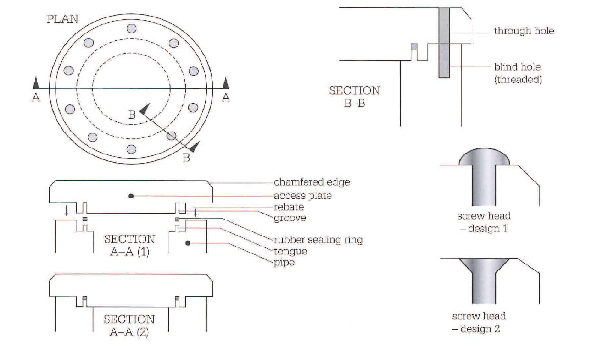
B. 3D forms of holes and fasteners
• The holes in the plate, for screws, are through holes- they go through the metal. The holes in the pipe wall are blind holes - they do not go all the way through. The screws which are intended to be screwed into these holes (by a turning action) have threads (helical grooves). The internal surfaces of the holes in the pipe walls are also threaded.
• The screws are machine screws, which have a constant thickness - their thickness is the same along their length. Many other screws are tapered - their thickness decreases towards the tip of the screw (the narrower end). Many screws are also pointed- the thickness of their tip reduces to zero.
• Two design options are shown for the screw heads. In Design 1, the screw has a round head, which is raised or proud - it is at a higher level than the surface of the plate. In Design 2, the screw has a flat head and is fully recessed - the head is within the thickness of the plate. The head is flush with (at the same level as) the top of the plate. To make the screw heads flush, the top of the hole and the sides of the screw head are chamfered. Recessing screws in this way is called countersinking - the screws are countersunk.

Задание 1. Найдите соответствия между предложениями 1)-5) и предложениями а) – е). Используйте информацию из текстов А и В.
- According to the drawing, we cut to a depth of 40 mm in a 60 mm thick plate.  - The edge of the die is cut off at 45 degrees.  - The tool is used as a scribe for scratching lines on the surfaces of ceramics.  - It's important to ensure the joint fits together properly.  - The surface needs to be flat. | - So the inside of the (groove/tongue) must be perfectly smooth.  - So the screw heads must be (raised/flush).  - It's a (blind/through) hole.  - That's why the end is (rounded/pointed), to make it sharp.  - It's (chamfered/rebated).

Задание 2. Прочитайте текст и переведите выделенные предложения на русский язык
Screw threads and conventional representations
The most common application of the helix is in a screw thread which follows the path of the helix. Screw threads may be either left or right hand and these are shown pictorially in Fig. 15.1. Notice the slope of the thread and the position of the index finger on each hand. The left hand thread is used for special applications and the right hand thread is the one normally used on nuts and bolts. The thread illustrated has a vee-section. 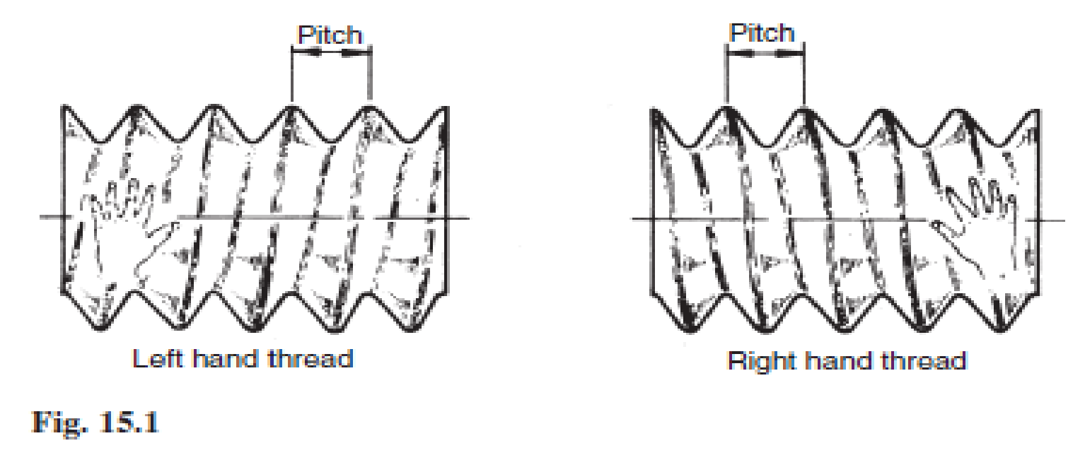
The following terms are associated with screw threads:
The thread pitch is the distance between corresponding points on adjacent threads. Measurements must be taken parallel to the thread axis.
The major diameter or outside diameter is the diameter over the crests of the thread, measured at right angles to the thread axis.
The crest is the most prominent part of the thread, internal or external.
The root lies at the bottom of the groove between two adjacent threads.
The flank of the thread is the straight side of the thread between the crest and root.
The minor diameter, root diameter or core diameter is the smallest diameter of the thread measured at right angles to the thread axis.
The effective diameter is measured at right angles to the thread axis and is the diameter on which the width of the spaces is equal to the width of the threads.
The lead of a thread is the axial movement of the screw in one revolution.
The terms are illustrated in Fig. 15.2. 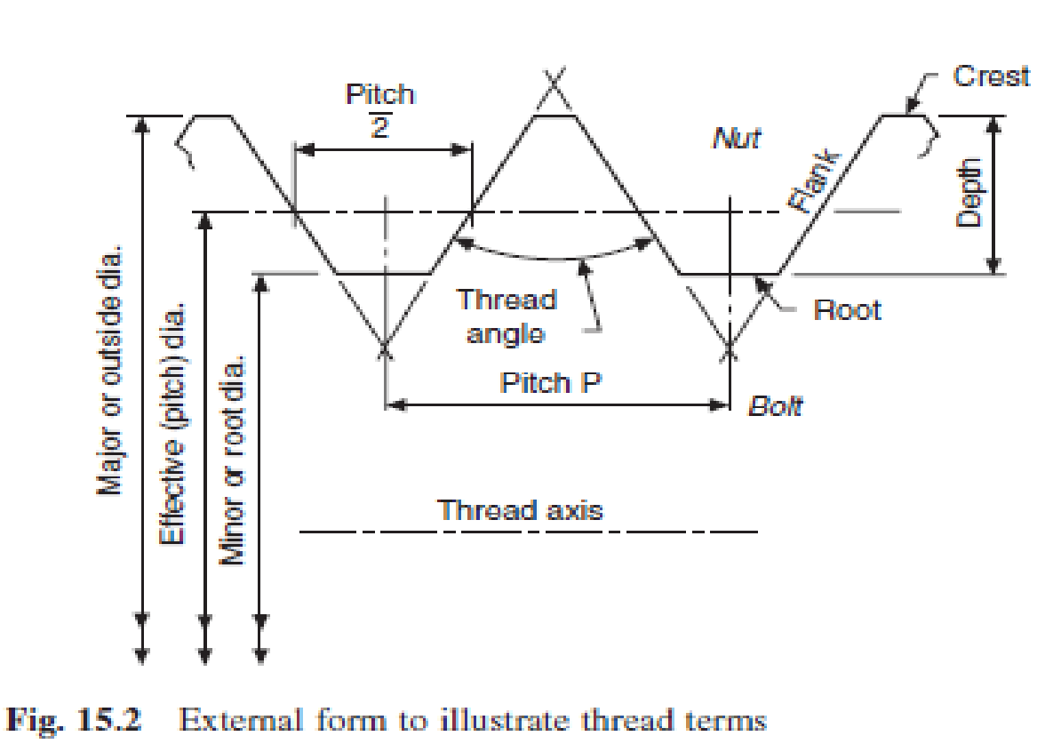

Грамматика
НЕЗАВИСИМЫЙ ПРИЧАСТНЫЙ ОБОРОТ
Сочетание существительного в общем падеже или местоимения в именительном падеже с любой формой причастия образует независимый причастный оборот.
В предложении этот оборот выполняет функцию сложного обстоятельства, на письме всегда отделяется запятой. Независимый причастный оборот может стоять как в первой, так и во второй части предложения.
1. /D. Mendeleyev/ having arranged the elements in a table, /the existence/ of yet unknown elements //could be predicted// – после того, как /Д.И. Менделеев/ //расположил// химические элементы в таблице, ученые смогли предсказать существование тогда еще неизвестных элементов.
2. /The CPU/ //controls// the operation of the entire system, /commands/ being issued to other parts of the system – центральный процессорный блок управляет работой всей системы, при этом команды посылаются к другим частям системы.
Обратите внимание! Если независимый причастный оборот располагается в первой части предложения до запятой (пример 1 – в этом случае во второй части предложения есть и подлежащее, и сказуемое, а в первой части – только подлежащее), он переводится придаточным предложением с союзами: когда, так как, если, после того, как (в зависимости от контекста).
Если независимый причастный оборот стоит во второй части предложения после запятой (пример 2 – в этом случае в первой части предложения есть и подлежащее, и сказуемое, а во второй – только подлежащее), он переводится самостоятельным предложением с союзами: причем (при этом), а, и, но – или без союза (в зависимости от контекста).
В некоторых случаях независимым причастным оборотам может предшествовать предлог with. Когда этот предлог стоит в начале предложения, то, помимо указанных выше союзов, при переводе используются союзы «теперь, когда».
With the experiments having been carried out, they started new investigations – теперь, когда (после того, как) опыты были закончены, они начали новые исследования.
Задание 3. Прочтите предложения, найдите в них независимый причастный оборот, переведите предложения, исходя из того, где находится этот оборот в предложении.
- The results of the arithmetic operations being returned to the accumulator, the storage register transfer them to main memory.
- Free electrons passing through a conductor, an electric current is generated.
- Free electrons pass through a conductor, an electric current being generated.
- The information capacity of a single bit being limited to two alternatives, codes are based on combination of bits.

Практическое занятие № 26
Тема: Архитектура компьютера
Назначение компьютерных сетей в современном мире, сервера. Защита информации. Что такое дистанционное образование, универсальное образование, открытое образование. Новые направления в области инфокоммуникационных систем Трудности перевода: Страдательный залог.

Прочитайте текст и выполните задания
A CNC Lathe
A Computer Numerical Control (CNC)lathe operatoris responsible for the operation and maintenance of CNC lathes. Most modern lathes are controlled with a computer. When a manufacturing company wants to create a part using a CNC lathe, the desired part must first be drafted using a computer aided design (CAD) program or a computer aided manufacturing (CAM) program. A CNC lathe operator then takes the design and downloads it to a CNC lathe, fits the right tools and then secures the workpiece into thelathe chuck. From there, the lathe automatically machines the piece to exactly what is shown in the design.
Jobs operating a CNC lathe are far more than just drafting a design, plugging it in and watching the lathe do its work. One of the most important parts of the entire process is making sure that thelathe toolsare sharp. When they become dull, the operator needs to remove and replace the worn tools.
Along with occasional tool replacement, a CNC lathe operator also is responsible for keeping a close eye on themachiningprocess, making sure that no problems arise and troubleshooting them when they do. Along with this, lathe operators also need to be able to remove and handle the machined parts.
Other duties of a CNClathe machine operatorinclude general maintenance of the machine itself. The operator should be reasonably familiar with the inner components of the lathe, so that he or she can make sure that the lathe is working properly and repair any problems without outside assistance. A CNC lathe operator also must have good hearing, because most lathe operators are required to monitor multiple lathes at once. For this reason, problems are often detected through sound alone.

Задание 1. Ответьте на вопросы, используя текст.
- What must be done when a manufacturing company wants to create a part using a CNC lathe?
- What does an operator do after the desired part has been drafted by CAD or CAM?
- What is one of the most important parts of the entire process?
- What is a CNC lathe operator also responsible for?
- What other duties of a machine operator do you know?
Задание 2. Переведите на русский язык в письменной форме абзацы 1 и 2.

Практическое занятие № 27
Тема: Архитектура компьютера Назначение портативных компьютеров. Соотношение размера и качества компьютера. Новые технологии. Трудности перевода: Инфинитив и Герундий.

Задание 1. Переведите на русский язык предложения, используя слова, изученные на занятиях ранее.
- By pressing the Handle Control Feedrate key, the jog handle can be used to control feedrate from 0% to 999% in ±1% increments.
- By pressing the Handle Control Spindle key, the jog handle can be used to control spindle speed in ±1% increments (from 0% to 999%).
- Synchronized tapping eliminates the need for expensive, floating tap holders, and prevents lead-thread distortion and start-thread pullout.
- It is necessary to properly secure the part to the table. This can be done in a number of ways, using vises, chucks or using T-bolts and toe clamps.
- Before loading tools the mill must be zero returned, which should have been done at machine power up.
- The Tool pocket table must be properly setup by the operator to avoid the possibility of damaging tools, the spindle or the tool changer.

Задание 2. Прочтите и переведите следующие предложения, обращая внимание на формы причастия и особенности их перевода.
1. Being obtained the results of the research were analyzed. 2. Having obtained the required results we informed the manager of this fact. 3. Having invented magnetic tapes the Germans used them as the secondary storage medium. 4.Having finished the research the scientists made the analysis of the data obtained. 5. Having been constructed recently a new electronic device has important applications in space exploration. 6. Having been regulated by the operator the equipment operated well.

Задание 3. Переведите предложения на русский язык, обращая внимание на перевод «Сложного дополнения» (См. таблицу выше)
- They expected us to have found the answer to the question.
- You must make him explain the results obtained
- We consider Mendeleev to be a great Russian scientist.
- We consider Tsiolkovsky to be the father of astronautics
- I heard the experiment to be finished by them last month.
- This force causes the objects to change direction.

Практическое занятие № 28
Тема: Архитектура компьютера Системы автоматизации производства: САМ и CAD. Технические чертежи. Стандарты ISO.

Прочитайте текст и выполните задания после него.

COMPUTER SCIENCE IN ENGINEERING
Computer science is a part of an applied mathematics. Specialists in computer science say that this field of knowledge is very interesting because it deals with computer-aided-design (CAD) and computer-aided-manufacturing (CAM).
Computers are intended to improve the productivity of labour of scientists, designers, engineers, managers, and other specialists, because computers offer quick and optimal solutions. One of the main goals of using CAD/CAM is to shorten the time between designing and manufacturing.
Computer aided design (CAD) is the process of creating a design, known as drafting, using computer technology. Computer aided manufacturing (CAM) is the use of computers andcomputer softwareto guide machines to manufacture something, usually a part that is mass-produced. There is always a strict relation between CAD and CAM and they are often used together.
CAD creates the design and CAM builds it. CAM is usually dependent on CAD. The use of CAD created designs offers an easy way of inputting information into a CAM software system.CAM and CAD are both referred to as part of an overall process known collectively as computer aided engineering (CAE). They can render things in either two dimensions (2D) or three dimensions (3D).
Many CAM machines haveCAD softwarebuilt-in, although not all designs require the use of a CAD created design. A CAD user will typically be an engineer with training in CAD software, whereas a CAM user will usually be a specially trained machinist. These types of machinists are highly skilled.

Задание 1. Ответьте на вопросы, используя текст.
- What do the abbreviations CAM and CAD mean?
- What is one of the main goals of using CAM and CAD?
- What is CAD?
- What is CAM
- Are they used together? How?
- What is CAE?
- What can you say about a CAD and CAM users?

Задание 2. Переведите на русский язык в письменной форме абзацы 2, 3, и 5.

Задание 3. Заполните пропуски в предложениях и запишите пропущенные слова в тетрадь.
- The use of CAD created … offers an easy way of … information into a CAM software system.
- CAM is the use of computers andcomputer softwareto … machines to manufacture something, usually a … that is mass-produced.
- A lot of CAM ... haveCAD software..., although not all designs ... the use of a CAD created design.
- Computers are … to improve the productivity of labour of scientists, designers, engineers, managers, and other specialists, because computers … quick and optimal ….

Практическое занятие № 29
Тема: Архитектура компьютера.
Робототехника. Роботы в промышленности.
Обобщение лексико-грамматического материала.

Прочитайте текст и выполните задания после него

ROBOTS IN MANUFACTURING
Today most robots are used in manufacturing operations. The applications of robots can be divided into three categories:
1. material handling
2. processing operations
3. assembly and inspection.
Material-handling is the transfer of material and loading and unloading of machines. Material-transfer applications require the robot to move materials or work parts from one to another. Many of these tasks are relatively simple: robots pick up parts from one conveyor and place them on another. Other transfer operations are more complex, such as placing parts in an arrangement that can be calculated by the robot. Machine loading and unloading operations utilize a robot to load and unload parts. This requires the robot to be equipped with a gripper that can grasp parts. Usually the gripper must be designed specifically for the particular part geometry.
In robotic processing operations, the robot manipulates a tool to perform a process on the work part. Examples of such applications include spot welding, continuous arc welding and spray painting. Spot welding of automobile bodies is one of the most common applications of industrial robots. The robot positions a spot welder against the automobile panels and frames to join them. Arc welding is a continuous process in which robot moves the welding rod along the welding seam. Spray painting is the manipulation of a spray-painting gun over the surface of the object to be coated. Other operations in this category include grinding and polishing in which a rotating spindle serves as the robot's tool.
The third application area of industrial robots is assembly and inspection. The use of robots in assembly is expected to increase because of the high cost of manual labour. But the design of the product is an important aspect of robotic assembly. Assembly methods that are satisfactory for humans are not always suitable for robots. Screws and nuts are widely used for fastening in manual assembly, but the same operations are extremely difficult for an one-armed robot.
Inspection is another area of factory operations in which the utilization of robots is growing. In a typical inspection job, the robot positions a sensor with respect to the work part and determines whether the part answers the quality specifications. In nearly all industrial robotic applications, the robot provides a substitute for human labour. There are certain characteristics of industrial jobs performed by humans that can be done by robots:
1. the operation is repetitive, involving the same basic work motions every cycle,
2. the operation is hazardous or uncomfortable for the human worker (for example: spray painting, spot welding, arc welding, and certain machine loading and unloading tasks),
3. the workpiece or tool is too heavy and difficult to handle,
4. the operation allows the robot to be used on two or three shifts.

Задание 1. Ответьте на вопросы к тексту:
1. How are robots used in manufacturing?
2. What is «material handling»?
3. What does a robot need to be equipped with to do loading and unloading operations?
4. What does robot manipulate in robotic processing operation?
5. What is the most common application of robots in automobile manufacturing?
6. What operations could be done by robot in car manufacturing industry?
7. What are the main reasons to use robots in production?
8. How can robots inspect the quality of production?
9. What operations could be done by robots in hazardous or uncomfortable for the human workers conditions?

Задание 2. Переведите на английский язык предложения из текста:
1. Существует несколько различных сфер использования автоматизации в производстве.
2. Для использования жесткой автоматизации необходимы большие инвестиции.
3. Жесткая автоматизация широко используется в химической промышленности.
4. Станки с числовым программным управлением — хороший пример программируемой
автоматизации.
5. Гибкая автоматизация делает возможным перепрограммирование оборудования.
6. Время простоя оборудования оборачивается большими убытками.
7. Использование гибкой автоматизации делает возможным производство разнообразной продукции.

