Практическая работа № 11
Тема: Числа и измерения
Числительные
 | Количественные | Порядковые
1 | one | first
2 | two | second
3 | three | third
4 | four | fourth
5 | five | fifth
6 | six | sixth
7 | seven | seventh
8 | eight | eighth
9 | nine | ninth
10 | ten | tenth
11 | eleven | eleventh
12 | twelve | twelfth
13 | thirteen | thirteenth
14 | fourteen | fourteenth
15 | fifteen | fifteenth
16 | sixteen | sixteenth
17 | seventeen | seventeenth
18 | eighteen | eighteenth
19 | nineteen | nineteenth
20 | twenty | twentieth
21 | twenty-one | twenty-first
22 | twenty-two | twenty-second
30 | thirty | thirtieth
40 | forty | fortieth
50 | fifty | fiftieth
60 | sixty | sixtieth
70 | seventy | seventieth
80 | eighty | eightieth
90 | ninety | ninetieth
100 | a (one) hundred | a (one) hundredth
Задание 1. Напишите по-английски.
- Количественные числительные:
3; 13; 30; 12; 24; 89; 325; 5, 197
- Порядковые числительные:
1; 2; 15; 23; 44; 1,000
Задание 2. Заполните пропуски числительными количественными или порядковыми.
- There are ________ months in a year.
- January is ________ month of the year.
- May is ________ month of the year.
- There are ________ months in winter.
- December is ________ month of the year and ________ month of winter.

Как читаются даты?
Числительное, обозначающее год, делится на две части – число сотен, а затем - число десятков и единиц.
1900 - nineteen hundred, in (the year) nineteen hundred
2004- two thousand four, in (the year) two thousand four
1905 - nineteen five, in (the year) nineteen five
Даты читаются следующим образом:
April12, 2001 1) on the twelfth of April, two thousand one
2) on April the twelfth, two thousand one
Задание 3. Напишите цифрами следующие даты.
- The first of March nineteen seventy-six.
- The fifth of December two thousand.
- The sixteenth of Мау nineteen five.
- The third of July nineteen hundred.
Задание 4. Напишите по-английски даты.
- 7 марта 1999 года;
- 1 сентября 1974 года;
- 22 апреля 1911 года;
- 11 марта 1951 года;
- 12 декабря 2024 года

Математические действия и знаки:
addition-сложение to multiply-умножить
subtraction-вычитание to divide-разделить
plus-плюс to equal-равняться, быть равным
minus-минус

Математические действия
- Сложение (Addition) 1 + 2 = 3
One and two is seven. One plus two equals eight.
- Вычитание (Subtraction): 7 – 6 = 1
Seven minus six is one. Seven subtract six equals fourteen.
- Multiplication (Умножение): 5 x 6 = 30
Five times six equals twenty-one. Five multiplied by six is twelve.
- Division (Деление): 9 ÷ 3 = 3
Nine divided by three equals three. Three goes into nine three times.
Дроби
Простые дроби  ½- one half (a half)  1/3- one third (a third)  3½- three and a half  5 1/7-five and a seventh  2/7- two sevenths | Десятичные дроби  0.7-nought (zero; O) point seven  0.002-zero point two zeros two  1.1-one point one  5.36-five point three six  65.5-sixty-five point five
Задание 5. Найдитесоответствия.
A. 17) ¾ a) three quatersB. 21) 60% a) one third
18) 5.68 b) two point two percent 22) 2.8 b) three and a half
19) 7 ½ c) five point six eight 23) 1/3 c) two point eight
20) 2.2% d) seven and a half 24) 3 ½ d) sixty percent

Задание 6. Выберите правильные вариант ответа.
25) Seventeen ... thirteen equals two hundred and twenty-one.
a) times (multiplied by)  b) divided by | c) minus  d) plus
26) Eighty-one ... thirty-three equals forty-eight
a) times (multiplied by)  b) divided by | c) minus  d) plus
27) One thousand and twenty-five ... twenty-five equals forty-one.
a) times (multiplied by)  b) divided by | c) minus  d) plus

Практическая работа № 12
Тема: Информационные технологии.
Прочитайте текст
1) Internet is а global network connecting millions of computers. Each Internet computer, called а host, is independent. Its operators саn choose which Internet services to use.
It is a system of Internet servers that support specially formatted documents. The documents are formatted in а markup language called HTML (Hyper Text Markup Language) that supports links to other documents, as well as graphics, audio, and video files. This means you саn jump from one document to another simply by clicking the mouse button.
2) What is the difference between the Internet and the World Wide Web? The Internet and the Web are two separate but related things.
The Internet connects millions of computers together globally, forming a network in which any computer can communicate with any other computer as long as they are both connected to the Internet. Information travels over the Internet in many languages known as protocols.
3) The World Wide Web, or simply Web is built on top of the Internet. The Web also utilizes browsers, such as Internet Explorer, to access Web documents called Web pages. Web documents also contain graphics, sounds, text and video. The Web is just one of the ways that information can be sent and received over the Internet. Internet is used for e-mail, not the Web. So the Web is just a portion of the Internet, but the two terms should not be confused.
4) Tim Berners-Lee (born in 1955) invented the World Wide Web. His first version of the Web was a program named "Enquire". He invented the system as a way of sharing scientific data (and other information) around the world, using the Internet, a world-wide network of computers and hypertext documents. He wrote the language HTML (HyperText Mark-up Language), the basic language for the Web, and devised URL' s (universal resource locators) to designate the location of each web page. HTTP (Hyper Text Transfer Protocol) was his set of rules for linking to pages on the Web. Berners-Lee is now a Principal Research Scientist at the Laboratory for Computer Science at MIT (Massachusetts Institute of Technology)

Words:

global network – глобальная сеть
to link - соединять, связывать
exchange - обмен
host - хост (компьютер, подключенный к сети Интернет)
to gain, get access – получить доступ
remote terminal - дистанционный (удаленный) терминал
server – сервер
formatted - форматированный
hypertextdocument - гипертекстовый документ
markup - разметка документа в НТМL-формате
HTML (НyperTextMarkupLanguage)- язык HTML (стандартный язык, используемый для создания страниц WWW)
URL(UniversalResourceLocator)- универсальный указатель информационного
ресурса (стандартизованная строка символов, указывающая местонахождение документа в сети Internet)
application - приложение, прикладная программа
browser (Webbrowser) - Wеb-браузер (программа для просмотра Wеb-страниц в сети Internet)

Задание 1. Найдите заголовок к каждому абзацу 1) – 4)
- What Is World Wide Web?
- Who Invented the World Wide Web?
- What Is Internet?
- What Is the Difference between Internet and World Wide Web

Задание 2. Ответьте на вопросы.

- What is Internet?
- What is World Wide Web?
- What is HTML?
- What is used for e-mails?
- Are World Wide Web and Internet the same?
- Who invented World Wide Web?
- What is URL?
- What is HTTP?

Задание 3. Письмо. Посмотрите на картинку ниже. Кэрол хочет устроиться на работу в Oxford International School. Посмотрите на персональные данные Кэрол и объявление о работе, и заполните пропуски в письме. Обратите внимание, из каких частей состоит письмо и на правила оформления. Запишите цифру и пропущенное слово.
Например, 1) - Road
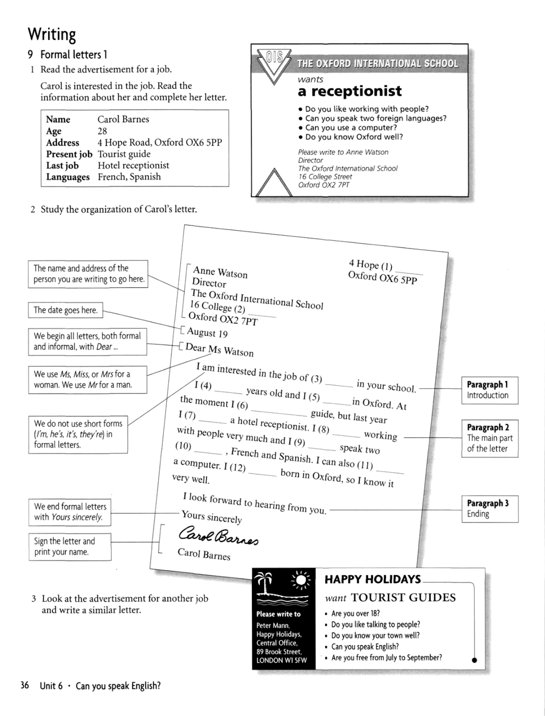

Практическая работа № 13
Тема: Научно-технический прогресс.
Gadgets

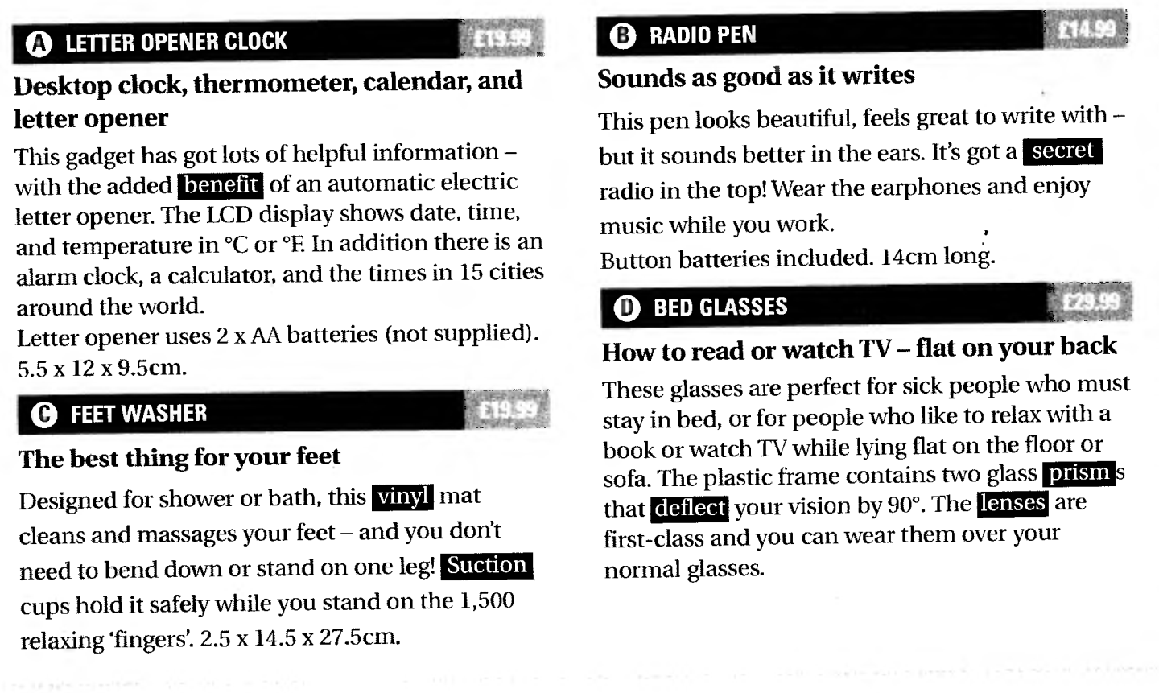
Задание 1. Прочитайте тексты (A-D) и найдите соответствия между гаджетами и данными ниже предложениями (1-6)
- These two don’t need batteries.
- This does two things.
- You use it standing up.
- You use these lying down.
- This can tell you how hot it is.
- You get free batteries with this.

Задание 2. Ниже даны определения гаджетам (7-13). Заполните пропуски выделенными словами из текста.

- A _________ is a good thing.
- A _________ is a triangular block of glass.
- ___________ are the pieces of glass you look through.
- ___________ holds/attaches with air pressure.
- ___________ is a type of plastic.
- ___________ means hidden.
- To ________ means to change direction.

Задание 3. Переведите на русский язык письменно абзацы А и D.

Практическая работа № 14
Тема: Образование.
Задание 1. Прочитайте текст, заполните пропуски (1-6) недостающими частями предложений, которые даны после текста (a-f). В тетрадях запишите цифру и букву, выбранного варианта.
Education in Britain
In England and Wales compulsory school begins at the age of five, but before that age children can go to a nursery school, 1)_______________________. School is compulsory till the children are 16 years old.
In Primary School and First School children learn to read and write and the basis of arithmetic. In the higher classes of Primary School (or in Middle School) children
2) ______________________schools, a foreign language. Then children go 3) _____________.
When students are 16 years old they may take an exam in various subjects in order to have a qualification. These qualifications can be either G.C.S.E. (General Certificate of Secondary Education) or "O level" (Ordinary level). After that students
4) __________________________as before. If they continue, when they are 18, they have to take further examinations which are necessary for getting into university or college.
Some parents choose private schools for their children. They are 5) ________________.
In England there are 47 universities, including the Open University which teaches via TV and radio, about 400 colleges and institutes of higher education. The oldest universities in England are Oxford and Cambridge. Generally, universities award two kinds of degrees:
6) ___________________________.

- very expensive but considered to provide a better education and good job opportunities.
- to the Secondary School.
- the Bachelor's degree and the Master's degree.
- can either leave school and start working or continue their studies in the same school
- learn geography, history, religion and, in some
- also called play school

Задание 2. Ответьте на вопросы по содержанию текста
- When does compulsory school begin?
- How long does a child stay in compulsory school?
- What subjects do children learn in Primary School?
- What kind of exam do students have to take when they are 16?
- Do students have to leave school at the age of 16 or to continue their studies?
- How do private schools differ from the regular ones?
- How many universities are there in England?
- What is the Open University?
- What kinds of degrees do universities award?

Задание 3. Найдите перевод русских предложений, обращая внимание на безличные и неопределенно-личные предложения. Напишите цифру и букву.

- Темно.  - Холодает.  - Можно увидеть.  - Здесь часто идет дождь.  - Поздно. Пора спать. | - It often rains here.  - It’s late. It’s time to go to bed.  - It’s dark.  - It’s getting cold.  - One can see.

Практическаяработа № 15
Тема: Отрасли промышленности.

 | Active | Passive
Participle I | drilling | being drilled
Participle II | - | drilled
Perfect Participle | having drilled | having been drilled

The man sitting at the table is our teacher. — Человек, сидящий за столом — наш учитель.
The houses being built in our town are not very high. — Дома, строящиеся в нашем городе, невысоки.
Going home I met an old friend. — Идя домой, я встретил старого друга.
Having finished work I went home. —Закончив работу, я пошел домой.
The book translated from English is interesting. — Книга, переведенная с английского языка, интересная.
Given the task he began to work. — Когда ему дали задание он начал работать.
Having solved the problem correctly they changed the answer. -Решив пример правильно, они поменяли ответ.

Задание 1. Переведите словосочетания с причастиями.
Participle I: Computers using superconducting material; the machine calculating mathematical problems; students coding the information.
Participle II: The given information; the name given to the machine; the coded data; the device used in World War II; the engine designed by engineers; dictation written the day before was corrected.
Задание 2. Переведите предложения с разными формами причастий.
1. Everybody looked at the dancing girl. 2. The little plump woman standing at the window is my grandmother. 3. The man playing the piano is Kate's uncle. 4. Entering the room, she turned on the light. 5. Coming to the theatre, she saw that the performance had already begun.
6. Having been tested, the new equipment was ready to use.
Задание 3. Выберите причастие (Participle I или Participle II)

1) a) The girl (writing, written) on the blackboard is our best pupil.
b) Everything (writing, written) here is quite right.
2) a) The house (surrounding, surrounded) by tall trees is very beautiful.
b) The wall (surrounding, surrounded) the house was very high.

3) (Connecting, connected) the two terminals of a battery we get a closed circuit.
4) The total number of electrons (emitting, emitted) by the cathode of a diode is always the same at a given operating temperature.
5) (Warmed/Having been warmed) to 0°C ice began to melt.
6) That all-natural substances are (composing/composed) of electrons is very well (knowing/known).
7) The book (writing, written) by this scientist is very interesting.
8) Translate the words (writing, written) on the blackboard.
9) (Going, gone) along the street, I met Mary and Ann

Практическая работа № 16
Тема: Отрасли промышленности
Прочтите текст и выполните задания после текста:
Machine Tools
1. Machine tools are the machinery used to process various materials in order to get desired shapes and properties.
2. The first generation of modern machine tools was introduced during the industrial revolution in the 18th century with the invention of steam engines. Machine tools opened an era of automation by providing the means to replace human work with mechanical work. In the early days automation with machine tools was performed using various kinematic mechanisms, but it evolved into programmable automation with the use of computer numerical control. Today, many machine tools are operated with electrical or hydraulic power and controlled by a computer.
3. The major application of automation using machine tools in the early years was in transfer lines. Many special-purpose machines were grouped together with a part-moving system, such as a conveyor, providing the transfer of parts from one machine to another. A specific operation was performed on each station, and the part was moved to the next station until the finished product was obtained. Recently, flexible automation has been actively pursued to cope with continuous and rapid change of product designs and cycles. In such systems, several numerically controlled machines are clustered together to perform a variety of jobs. Programs are used, instead of inflexible mechanisms, to control the machines, so that the system can easily adapt to different job requirements.
Задание 1. Переведите 2 абзац текста письменно.
Задание 2. Найдите в 3-ем абзаце текста термины, выпишите их и с помощью словаря переведите.
Задание 3. Найдите в тексте 4-5 Причастий, выпишите их.
Задание 4. Вставьте to write в нужной форме.
- We often ... letters to our parents.
- What ... you ... now?
- Yesterday they ...... tests from 10 till12 o'clock.
- Who ...... this letter?
- I ...... some letters last week.
- What ... you ... tomorrow at 10?
- When I came to her, she ... ... а letter.
- .. . you ... letters tomorrow?
- I ... not ... this letter now. I ..... .it in some days.
- ... he ... his home task now?
- What ... she ... in the evening yesterday?
- As а rule, he ... tests well.

Практическая работа № 17
Тема: Выбор профессии.
Прочтите текст и выполните задания после текста:
A job of a machine operator
Hello, I want to tell about my profession. I study at the college. Soon I’ll be a technician in mechanical engineering or a machine operator. Mechanical engineering deals with different kinds of machine tools and operating them.
It’s a very important profession. Reading and using drawings and other supporting documents, and working out how to do the job: i.e. selection of speed, tools and materials, fixing tools and work pieces, adjusting machine tools, machining rotating parts to various shapes and surfaces to specified dimensions, accuracy and surface finishes, machine thread-cutting, maintenance and handling of machine tools.
In workshops and factories of general engineering companies or smaller manufacturers and service organizations, where there may be noise, grease and other dirt in the working environment.
Conventional and numerically controlled lathes, turret lathes, boring machines, and other machines including, at times, automated manufacturing units, hand tools for normal maintenance work and their own hands. The materials processed are various metals. You need education/training to skilled craft level, spatial imagination, accuracy, technical imagination, etc.

Задание 1. Ответьте на вопросы
- What is your name?
- Where are you from?
- How old are you?
- What is your future profession?
- Where do you study?
- Why do you like this profession?
- Who are machine operators and what do they do?
- What are the activities of the job?
- Where is it done and under what conditions?
- What tools/equipment do machine operators use?
- What do you need to succeed?
- Is it a dangerous profession or not?
- What protective clothes must you wear?
- Where do you want to work? (I want to work _________)
- Is it a good craft and well-paid job?
- Do you want to work abroad (заграницей)?

Задание 2. Составьте диалог на тему «Моя будущая профессия», «Мои планы на будущее», «Мой взгляд на профессию», поработайте в парах или мини группах. Можете использовать текст, вопросы из Задания 1 и свои предложения.

