Практическая работа № 25
Прочитайте текст и выполните задание после него.
3D component features
A. 3D forms of edges and joints
The plan and sections below show the end of a stainless-steel pipe and an access plate, which are part of a production line at a chemical manufacturing plant. The top edge of the plate is chamfered- at an angle of 45 degrees with the sides of the plate. All the other edges are square (90 degrees). Around the bottom of the plate is a rebate – an internal corner. The top of the pipe is also rebated around the inside, so that the bottom of the plate can slot into the top of the pipe. In the rebate on the pipe, there is a ridge - a long, thin, raised surface. On the plate, a groove or channel is cut into the metal. The ridge on the pipe slots into this groove to form a tongue and- groove joint (the ridge is the tongue). When the two are slotted together there is a cavity or void (a hollow space) between the top of the tongue and the end of the groove. This is to accommodate (provide a space for) a rubber sealing ring.
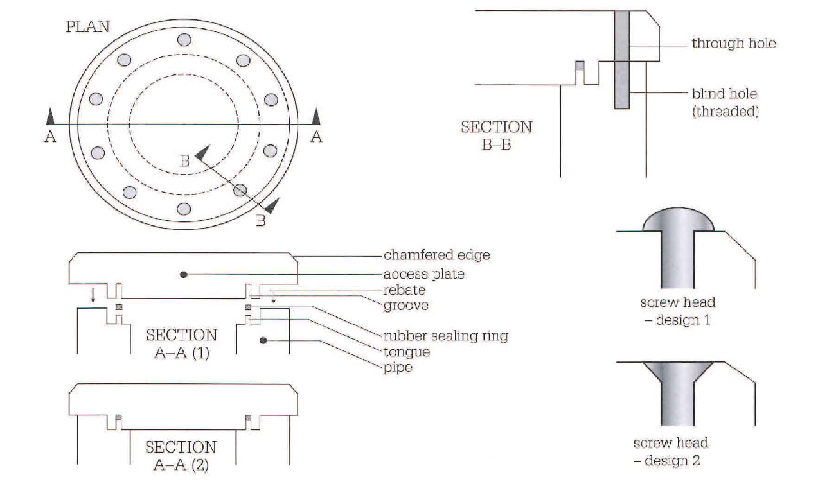
B. 3D forms of holes and fasteners
• The holes in the plate, for screws, are through holes- they go through the metal. The holes in the pipe wall are blind holes - they do not go all the way through. The screws which are intended to be screwed into these holes (by a turning action) have threads (helical grooves). The internal surfaces of the holes in the pipe walls are also threaded.
• The screws are machine screws, which have a constant thickness - their thickness is the same along their length. Many other screws are tapered - their thickness decreases towards the tip of the screw (the narrower end). Many screws are also pointed- the thickness of their tip reduces to zero.
• Two design options are shown for the screw heads. In Design 1, the screw has a round head, which is raised or proud - it is at a higher level than the surface of the plate. In Design 2, the screw has a flat head and is fully recessed - the head is within the thickness of the plate. The head is flush with (at the same level as) the top of the plate. To make the screw heads flush, the top of the hole and the sides of the screw head are chamfered. Recessing screws in this way is called countersinking - the screws are countersunk.
Задание 1. Найдите соответствия между предложениями 1)-5) и предложениями а) – е). Используйте информацию из текстов А и В.
- According to the drawing, we cut to a depth of 40 mm in a 60 mm thick plate.  - The edge of the die is cut off at 45 degrees.  - The tool is used as a scribe for scratching lines on the surfaces of ceramics.  - It's important to ensure the joint fits together properly.  - The surface needs to be flat. | - So the inside of the (groove/tongue) must be perfectly smooth.  - So the screw heads must be (raised/flush).  - It's a (blind/through) hole.  - That's why the end is (rounded/pointed), to make it sharp.  - It's (chamfered/rebated).

Задание 2. Прочитайте текст и переведите выделенные предложения на русский язык
Screw threads and conventional representations
The most common application of the helix is in a screw thread which follows the path of the helix. Screw threads may be either left or right hand and these are shown pictorially in Fig. 15.1. Notice the slope of the thread and the position of the index finger on each hand. The left hand thread is used for special applications and the right hand thread is the one normally used on nuts and bolts. The thread illustrated has a vee-section. 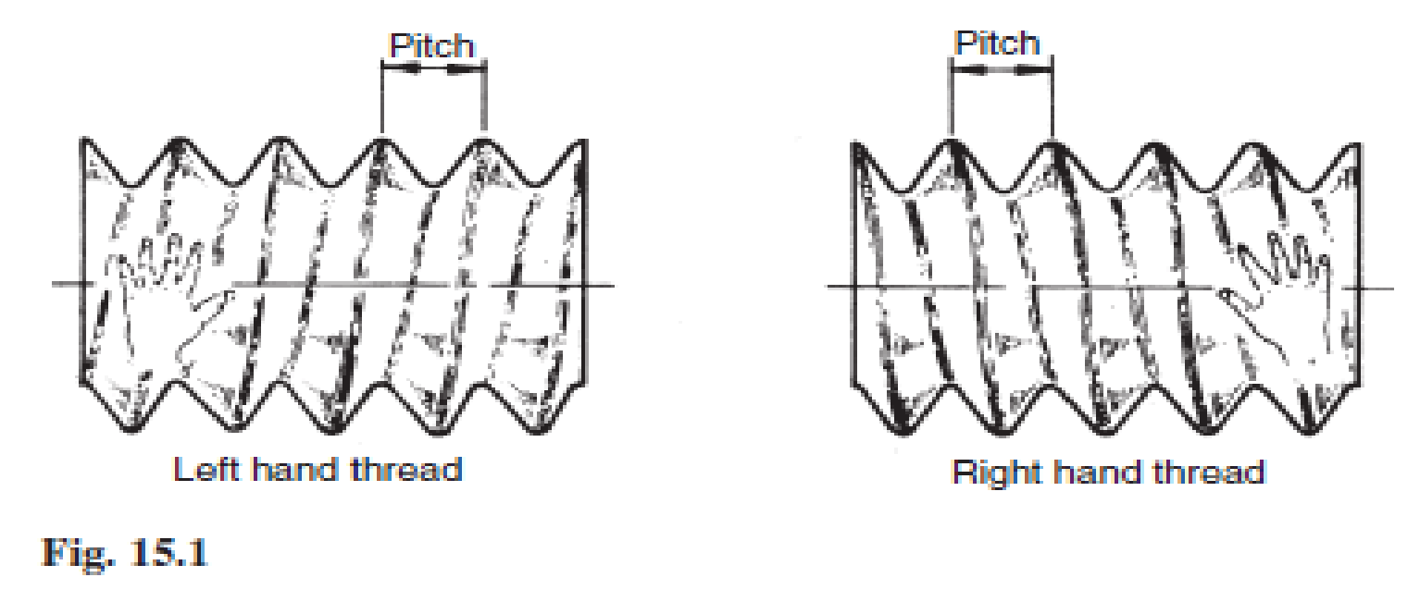
The following terms are associated with screw threads:
The thread pitch is the distance between corresponding points on adjacent threads. Measurements must be taken parallel to the thread axis.
The major diameter or outside diameter is the diameter over the crests of the thread, measured at right angles to the thread axis.
The crest is the most prominent part of the thread, internal or external.
The root lies at the bottom of the groove between two adjacent threads.
The flank of the thread is the straight side of the thread between the crest and root.
The minor diameter, root diameter or core diameter is the smallest diameter of the thread measured at right angles to the thread axis.
The effective diameter is measured at right angles to the thread axis and is the diameter on which the width of the spaces is equal to the width of the threads.
The lead of a thread is the axial movement of the screw in one revolution.
The terms are illustrated in Fig. 15.2.
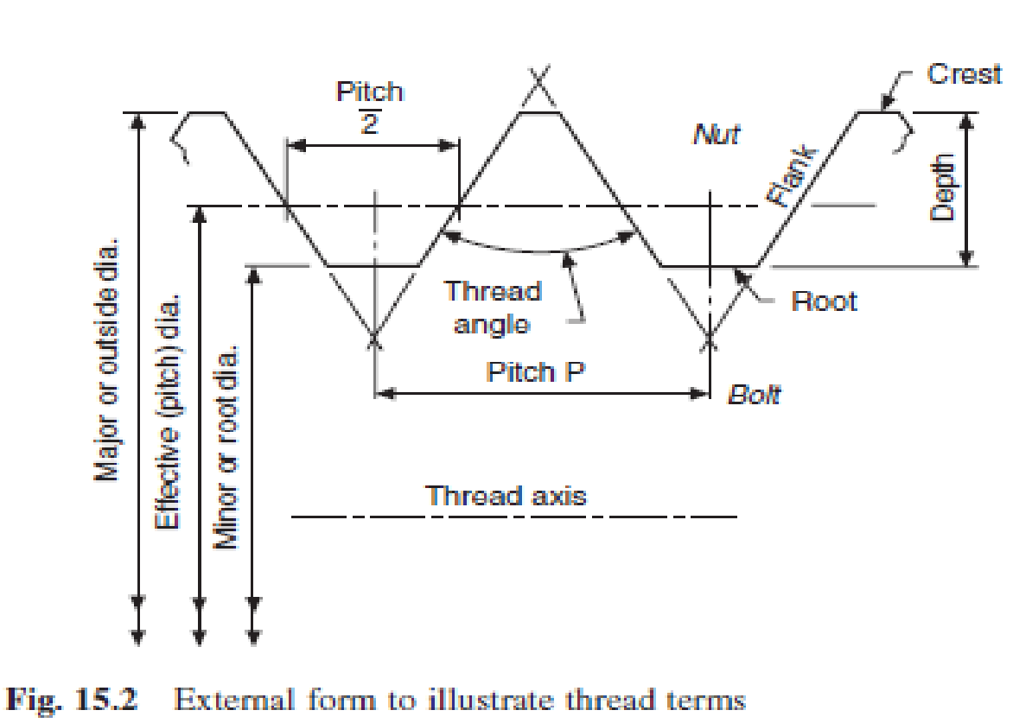

Грамматика
НЕЗАВИСИМЫЙ ПРИЧАСТНЫЙ ОБОРОТ
Сочетание существительного в общем падеже или местоимения в именительном падеже с любой формой причастия образует независимый причастный оборот.
В предложении этот оборот выполняет функцию сложного обстоятельства, на письме всегда отделяется запятой. Независимый причастный оборот может стоять как в первой, так и во второй части предложения.
1. /D. Mendeleyev/ having arranged the elements in a table, /the existence/ of yet unknown elements //could be predicted// – после того, как /Д.И. Менделеев/ //расположил// химические элементы в таблице, ученые смогли предсказать существование тогда еще неизвестных элементов.
2. /The CPU/ //controls// the operation of the entire system, /commands/ being issued to other parts of the system – центральный процессорный блок управляет работой всей системы, при этом команды посылаются к другим частям системы.
Обратите внимание! Если независимый причастный оборот располагается в первой части предложения до запятой (пример 1 – в этом случае во второй части предложения есть и подлежащее, и сказуемое, а в первой части – только подлежащее), он переводится придаточным предложением с союзами: когда, так как, если, после того, как (в зависимости от контекста).
Если независимый причастный оборот стоит во второй части предложения после запятой (пример 2 – в этом случае в первой части предложения есть и подлежащее, и сказуемое, а во второй – только подлежащее), он переводится самостоятельным предложением с союзами: причем (при этом), а, и, но – или без союза (в зависимости от контекста).
В некоторых случаях независимым причастным оборотам может предшествовать предлог with. Когда этот предлог стоит в начале предложения, то, помимо указанных выше союзов, при переводе используются союзы «теперь, когда».
With the experiments having been carried out, they started new investigations – теперь, когда (после того, как) опыты были закончены, они начали новые исследования.
Задание 3. Прочтите предложения, найдите в них независимый причастный оборот, переведите предложения, исходя из того, где находится этот оборот в предложении.
- The results of the arithmetic operations being returned to the accumulator, the storage register transfer them to main memory.
- Free electrons passing through a conductor, an electric current is generated.
- Free electrons pass through a conductor, an electric current being generated.
- The information capacity of a single bit being limited to two alternatives, codes are based on combination of bits.

