UNIT 5
1. Прочитайте текст, запишите в таблицу выделенные термины в соответствии со схемой. Переведите выделенные термины на русский язык.

The electrical system of a car
The battery stores electricity. When you turn the ignition key, electricity flows from the battery to the starter motor. This turns the engine. The engine drives the alternator. This acts as a generator and produces electricity. It also charges the battery. The alternator produces alternating current (AC). A rectifier pack changes AC to DC (direct current). Diodes in the rectifier pack make sure that output from the alternator flows in one direction to the battery. But current can’t flow from the battery to the alternator. Electrical current runs through the cables of the car’s electrical circuit. The current leaves the battery through the positive terminal. It returns to the battery through the negative terminal.
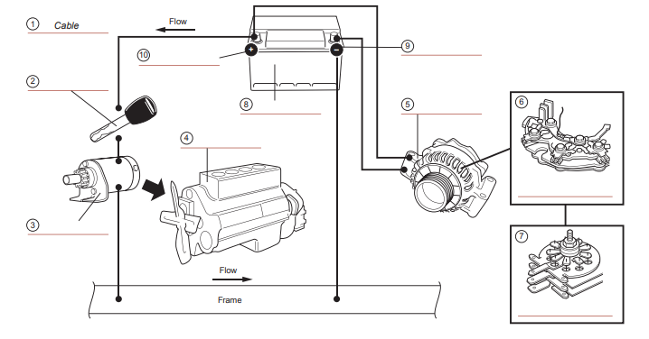
термин | перевод | термин | перевод
1 cable | кабель | 6
2 |  | 7
3 |  | 8
4 |  | 9
5 |  | 10

2. Выделите слово, заменяющее в тексте данное местоимение.
1. This (line 2 ) | a) starter motor | b) ignition key | c) battery
2. This (line 2 ) | a) engine | b) generator | c) alternator
3. It (line 3 ) | a) generator | b) electricity | c) alternator
4. It (line 7 ) | a) battery | b) current | c) terminal

3. Соотнесите устройство с функцией.
1 The battery |  | a) carry electricity to different parts of the car.
2 The cables |  | b) generates electricity for the car and charges the battery.
3 The engine |  | c) changes AC to DC.
4 The alternator |  | d) drives the wheels of the car and the alternator.
5 The diodes |  | e) stores electricity for the car.
6 The rectifier pack |  | f) allow electrical current to flow in one direction only

4. Впишите подходящий по смыслу предлог.

around / from / into / out of / through / to

1. Electricity flows ___________________the electrical cables.
2. Electricity flows ___________________the electrical circuit.
3. Electricity flows ___________________the alternator the battery.
4. Electricity flows ___________________the positive terminal of the battery the starter motor.

5 Complete the sentences. Use the present simple, with or without not.

1 If the battery is charged and the lights switch is on, current flows from the battery to the lights.
(current / flow / battery / lights)

2 If the battery is charged and the radio switch is off,
(current / flow / battery / radio)

3 If the battery is not charged,
(current / flow / starter motor / battery)

4 If the alternator is broken,
(current / flow / alternator / battery)

5 If no electricity flows from the alternator to the battery,
(battery / become flat)

6 If the battery is flat,
no (electricity / flow / battery / starter motor)

7 If the ignition is off,
(electricity / flow / around / electrical circuit)

