Практическое занятие № 21
Тема 3.3 Детали и инструменты. Простой ручной инструмент. Крепеж. Станки. Требования техники безопасности к организации рабочего места.
Трудности перевода отдельных грамматических структур
Цель:
- закрепление и систематизация теоретических знаний по лексической и грамматическим темам;
- совершенствование навыков чтения и перевода текстов
Прочтите текст и выполните задания после текста:
Machine Tools
1. Machine tools are the machinery used to process various materials in order to get desired shapes and properties.
2. The first generation of modern machine tools was introduced during the industrial revolution in the 18th century with the invention of steam engines. Machine tools opened an era of automation by providing the means to replace human work with mechanical work. In the early days automation with machine tools was performed using various kinematic mechanisms, but it evolved into programmable automation with the use of computer numerical control. Today, many machine tools are operated with electrical or hydraulic power and controlled by a computer.
3. The major application of automation using machine tools in the early years was in transfer lines. Many special-purpose machines were grouped together with a part-moving system, such as a conveyor, providing the transfer of parts from one machine to another. A specific operation was performed on each station, and the part was moved to the next station until the finished product was obtained. Recently, flexible automation has been actively pursued to cope with continuous and rapid change of product designs and cycles. In such systems, several numerically controlled machines are clustered together to perform a variety of jobs. Programs are used, instead of inflexible mechanisms, to control the machines, so that the system can easily adapt to different job requirements.
Задание 1. Переведите 2 абзац текста письменно.

STEEL
The most important metal in industry is iron and its alloy — steel. Steel is an alloy of iron and carbon. It is strong and stiff, but corrodes easily through rusting, although stainless and other special steels resist corrosion.
The amount of carbon in a steel influences its properties considerably. Steels of low carbon content (mild steels) are quite ductile and are used in the manufacture of sheet iron, wire, and pipes. Medium-carbon steels containing from 0.2 to 0.4 per cent carbon are tougher and stronger and are used as structural steels. Both mild and medium-carbon steels are suitable for forging and welding. High-carbon steels contain from 0.4 to 1.5 per cent carbon, are hard and brittle and are used in cutting tools, surgical instruments, razor blades and springs.
Tool steel, also called silver steel, contains about 1 per cent carbon and is strengthened and toughened by quenching and tempering.
The inclusion of other elements affects the properties of the steel. Manganese gives extra strength and toughness. Steel containing 4 per cent silicon is used for transformer cores or electromagnets because it has large grains acting like small magnets. The addition of chromium gives extra strength and corrosion resistance, so we can get rust-proof steels. Heating in the presence of carbon or nitrogen-rich materials is used to form a hard surface on steel (case-hardening). High-speed steels, which are extremely important in machine-tools, contain chromium and tungsten plus smaller amounts of vanadium, molybdenum and other metals.

Vocabulary:
alloy — сплав
carbon— углерод
stiff — жесткий
to corrode — разъедать, ржаветь
rusty — ржавый
stainless — нержавеющий
to resist — сопротивляться
considerably — значительно, гораздо
tough — крепкий, жесткий, прочный, выносливый
forging — ковка
welding — сварка
brittle — хрупкий, ломкий
cutting tools — режущие инструменты
surgical instruments — хирургические инструменты
blade — лезвие
spring — пружина
inclusion — включение
to affect — влиять
manganese — марганец
silicon — кремний
rust-proof — нержавеющий
nitrogen — азот
tungsten — вольфрам

Задание 2. Ответьте на вопросы по тексту
- What is steel?
- What are the main properties of steel?
- What are the drawbacks of steel?
- What kinds of steel do you know? Where are they used?
- What gives the addition of manganese, silicon and chromium to steel?
- What can be made of mild steels (medium-carbon steels, high-carbon steels)?
- What kind of steels can be forged and welded?
- How can we get rust-proof (stainless) steel?
- What is used to form a hard surface on steel?
- What are high-speed steels alloyed with?

Задание 3. Найдите в тексте перевод слов и словосочетаний
- сплав железа и углерода
- прочный и жесткий
- легко коррозирует
- нержавеющая сталь
- низкое содержание углерода
- ковкость
- листовое железо, проволока, трубы
- конструкционные стали
- пригодны для ковки и сварки
- твердый и хрупкий
- режущие инструменты
- хирургические инструменты
- инструментальная сталь
- упрочнять
- добавление марганца (кремния, хрома, вольфрама, молибдена, ванадия)

Задание 4. Прочитайте текст и напишите, верны ли утверждения после текста (Т) или нет (F). Исправьте неверные утверждния.
The second main category of steel is alloy steels, which consist of iron, carbon and one or more alloying metals. Specific grades of alloy steel include:
• low alloy steels, which contain 90% or more iron, and up to approximately 10% of alloying metals such as chromium, nickel, manganese, molybdenum and vanadium
• high strength low alloy steels (HSLA), which contain smaller quantities of the above metals (typically less than 2%)
• stainless steels, which contain chromium as well as other metals - such as nickel - and which do not rust.
• tool steels, which are extremely hard, and are used in cutting tools. They contain tungsten and/or cobalt. A widely used grade of tool steel is high-speed steel, which is used in cutting tools that operate at high temperatures, such as drill bits.

- Steel is an alloy of iron and carbon.
- Alloy steels contain carbon.
- Chromium and nickel are used as alloying metals in steel.
- Low alloy steels contain more chromium than iron.
- Stainless steel is an alloy steel.
- Tungsten is added to steel to make it softer.
High-speed steel is suitable for making cutting tools that get very hot.
Практическое занятие № 22
Тема 3.4 Наладка станков.
Станки с ЧПУ. Программирование станков с ЧПУ. Системы автоматизации. Обслуживание станков. Системы автоматизации производства. Заказ-наряд. Техническое задание. Сослагательное наклонение. Типы вопросов. Модальные глаголы.
Цель:
- закрепление и систематизация теоретических знаний по лексической и грамматическим темам;
- совершенствование навыков чтения и перевода текстов

Прочтите текст и выполните задания после текста:

MACHINE-TOOLS AND PROCESSES
Machine-tools are used to shape metals and other materials. The material to be shaped is called the workpiece. Most machine-tools are now electrically driven. Machine-tools with electrical drive are faster and more accurate than hand tools: they were an important element in the development of mass-production processes, as they allowed individual parts to be made in large numbers so as to be interchangeable.
All machine-tools have facilities for holding both the workpiece and the tool, and for accurately controlling the movement of the cutting tool relative to the workpiece. Most machining operations generate large amounts of heat, and use cooling fluids (usually a mixture of water and oils) for cooling and lubrication.
Machine-tools usually work materials mechanically but other machining methods have been developed lately. They include chemical machining, spark erosion to machine very hard materials to any shape by means of a continuous high-voltage spark (discharge) between an electrode and a workpiece. Other machining methods include drilling using ultrasound, and cutting by means of a laser beam. Numerical control of machine-tools and flexible manufacturing systems have made it possible for complete systems of machine-tools to be used flexibly for the manufacture of a range of products.

Задание 1. Закончите предложения, выбрав соответствующие варианты
- Machine-tools are…
А) now electrically driven
В) an important element
С) used to shape metals and other materials

- The material to be shaped is…
А) allowed individual parts
В) called the workpiece
С) usually work materials mechanically

- Other machining methods include…
А) drilling using ultrasound, and cutting by means of a laser beam.
В) chemical machining, spark erosion to machine very hard materials to any shape by means of a continuous high-voltage
С) facilities for holding both the workpiece

Задание 2. Составьте и запишите пары: термин-перевод
- electrically driven
- The material to be shaped
- high-voltage spark
- more accurate
- of mass-production processes

- обрабатываемый материал
- более точный
- электропривод
- процесс массового производства
- высоковольтный разряд

Задание 3. Найдите в правой колонке русские эквиваленты слов и словосочетаний:
- non-ferrous metal  - turning mill  - roughing operations  - finishing operations  - turret head  - side head  - facing  - drilling  - high rigidity  - gearbox  - multidisk friction clutch  - work feed  - table speed  - cross-rail  - V-belt |  | - зубчатая передача  - многодисковая фрикционная муфта  - скорость движения стола  - черновая обточка  - токарный станок  - высокая жесткость  - чистовая обточка  - торцевое точение  - револьверная головка  - боковой суппорт  - сверление  - клинообразный ремень  - цветные металлы (не железистые)  - поперечина (траверса)  - подача заготовки

Прочитайте текст и выполните задание после него.
3D component features
A. 3D forms of edges and joints
The plan and sections below show the end of a stainless steel pipe and an access plate, which are part of a production line at a chemicals manufacturing plant. The top edge of the plate is chamfered- at an angle of 45 degrees with the sides of the plate. All the other edges are square (90 degrees). Around the bottom of the plate is a rebate – an internal corner. The top of the pipe is also rebated around the inside, so that the bottom of the plate can slot into the top of the pipe. In the rebate on the pipe, there is a ridge - a long, thin, raised surface. On the plate, a groove or channel is cut into the metal. The ridge on the pipe slots into this groove to form
a tongue and- groove joint (the ridge is the tongue). When the two are slotted together there is a cavity or void (a hollow space) between the top of the tongue and the end of the groove. This is to accommodate (provide a space for) a rubber sealing ring.
B. 3D forms of holes and fasteners
• The holes in the plate, for screws, are through holes- they go through the metal. The holes in the pipe wall are blind holes - they do not go all the way through. The screws which are intended to be screwed into these holes (by a turning action) have threads (helical grooves). The internal surfaces of the holes in the pipe walls are also threaded.
• The screws are machine screws, which have a constant thickness - their thickness is the same along their length. Many other screws are tapered - their thickness decreases towards the tip of the screw (the narrower end). Many screws are also pointed- the thickness of their tip reduces to zero.
• Two design options are shown for the screw heads. In Design 1, the screw has a round head, which is raised or proud - it is at a higher level than the surface of the plate. In Design 2, the screw has a flat head and is fully recessed - the head is within the thickness of the plate. The head is flush with (at the same level as) the top of the plate. To make the screw heads flush, the top of the hole and the sides of the screw head are chamfered. Recessing screws in this way is called countersinking - the screws are countersunk.
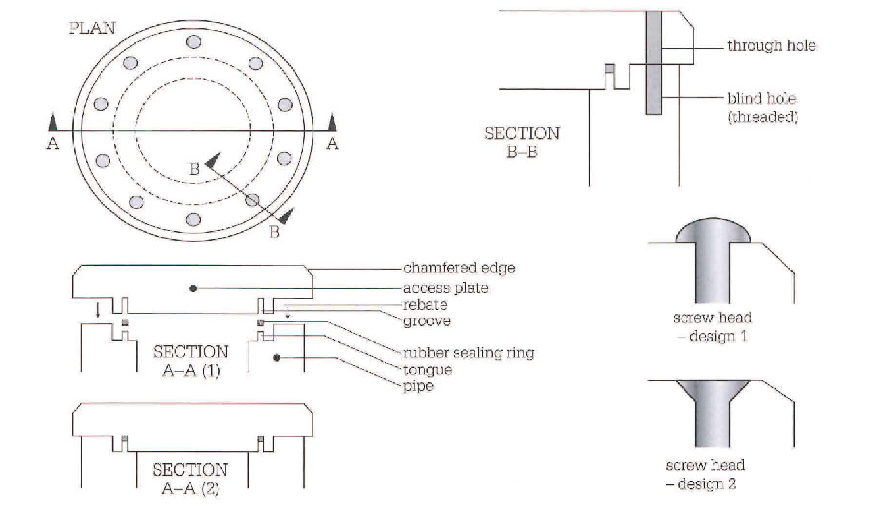
Задание 4. Найдите соответствия между предложениями 1)-5) и предложениями а) – е). Используйте информацию из текстов А и В.
- According to the drawing, we cut to a depth of 40 mm in a 60 mm thick plate.  - The edge of the die is cut off at 45 degrees.  - The tool is used as a scribe for scratching lines on the surfaces of ceramics.  - It's important to ensure the joint fits together properly.  - The surface needs to be flat. | - So the inside of the (groove/tongue) must be perfectly smooth.  - So the screw heads must be (raised/flush).  - It's a (blind/through) hole.  - That's why the end is (rounded/pointed), to make it sharp.  - It's (chamfered/rebated).

