Практическая работа № 30
Тема: Компьютерные технологии в промышленности. Системы автоматизации производства.
Цель:
- совершенствование навыков чтения и понимания текстов профессиональной направленности.
- совершенствование навыков перевода текстов профессиональной направленности

Прочитайте текст и выполните задания после текста.
TYPES OF AUTOMATION
Applications of Automation and Robotics in Industry
Manufacturing is one of the most important application area for automation technology. There are several types of automation in manufacturing. The examples of automated systems used in manufacturing are described below.
Fixed automation, sometimes called «hard automation» refers to automated machines in which the equipment configuration allows fixed sequence of processing operations. These machines are programmed by their design to make only certain processing operations. They are not easily changed over from one product style to another. This form of automation needs high initial investments and high production rates. That is why it is suitable for products that are made in large volumes. Examples of fixed automation are machining transfer lines found in the automobile industry, automatic assembly machines and certain chemical processes.
Programmable automation is a form of automation for producing products in large quantities, ranging from several dozen to several thousand units at a time. For each new product the production equipment must be reprogrammed and changed over. This reprogramming and changeover take a period of non-productive time.
Production rates in programmable automation are generally lower than in fixed automation, because the equipment is designed to facilitate product changeover rather than for product specialization. A numerical-control machine-tool is a good example of programmable automation. The program is coded in computer memory for each different product style and the machine-tool is controlled by the computer program.
Flexible automation is a kind of programmable automation. Programmable automation requires time to reprogram and change over the production equipment for each series of new product. This is lost production time, which is expensive. In flexible automation the number of products is limited so that the changeover of the equipment can be done very quickly and automatically. The reprogramming of the equipment in flexible automation is done at a computer terminal without using the production equipment itself. Flexible automation allows a mixture of different products to be produced one right after another.
Задание 1. Дополните словарь незнакомыми словами из текста.
Vocabulary
equipment — оборудование
sequence — последовательность
initial — первоначальный, начальный
investment — инвестиция, вклад
to facilitate — способствовать
rate — скорость, темп
assembly machines — сборочные машины
quantity — количество
non-productive — непроизводительный
changeover — переход, переналадка

Задание 2. Ответьте на вопросы развернутым предложением
- What is the most important application of automation?
- What are the types of automation used in manufacturing?
- What is fixed automation?
- What are the limitations of hard automation?
- What is the best example of programmable automation?
- What are the limitations of programmable automation?
- What are the advantages of flexible automation?
- Is it possible to produce different products one after another using automation technology?

Задание 3 Найдите в тексте перевод следующих словосочетаний и запишите их.
- сфера применения
- фиксированная последовательность операций
- автоматические сборочные машины
- определенные химические процессы
- станок с числовым программным управлением
- потерянное производственное время
- разнообразная продукция

Практическая работа № 31
Тема: Инструкции. Трудности перевода: Сложное дополнение.
Цель:
- закрепление и систематизация теоретических знаний по лексической и грамматическим темам;
- совершенствование навыков чтения и понимания текстов профессиональной направленности.
Посмотрите на картинку и прочитайте инструкции. Выполните задания после текста.

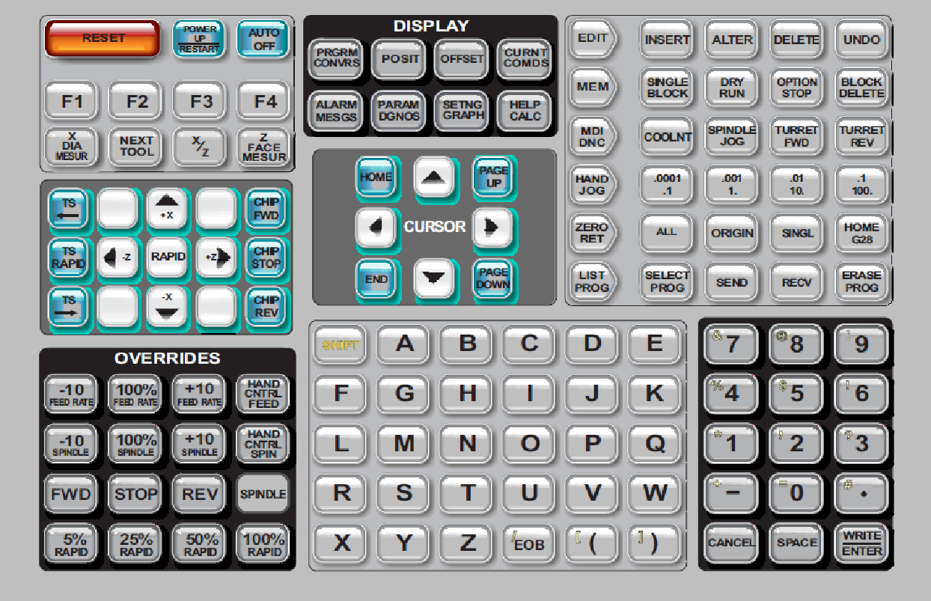
PENDANT KEYBOARD
The keyboard is broken up into eight sections: Function Keys, Jog Keys, Override Keys, Display Keys, Cursor Keys, Alpha Keys, Mode Keys and Number Keys. In addition there are miscellaneous keys and features located on the pendant and keyboard.
Power On- Turns the machine on.
Power Off- Turns the machine off.
Spindle Load Meter - Displays the spindle load, in percent.
Emergency Stop - This stops all axes motion, stops the spindle, turret, and turns off the coolant pump.
Jog Handle - This is used to jog all axes. It can also be used to scroll through program code or menu items while editing.
Cycle Start - Starts a program. This button is also used to start a program in Graphics mode.
Feed Hold - Will stop all axis motion. Note: Spindle will continue to turn during cutting.
Reset - Will stop the machine (axes, spindle, coolant pump, and turret are stopped). This is not a recommended method to stop the machine, as it may be difficult to continue from that point.
Power Up/Restart - When this key is pressed, the axes will return to the machine zero position and a tool change may occur. See Setting 81 in the Settings chapter for more information. This will not work for toolroom lathes, subspindle lathes, or automatic parts loader (APL).
Auto Off - Automatically positions axes to machine zero and prepares the machine for power down.
Memory Lock Key Switch - This switch prevent the operator from editing programs and from altering settings when turned to the locked position.
Work Light Switch - This switch will turn on the work light inside of the machine.
Keyboard Beeper - Located at the top of the parts tray. The volume can be adjusted by turning the cover.
Задание 1. Ответьте на вопросы развернутым предложением, используя инструкцию выше.
- How many sections does the keyboard have? What are they?
- What key turns the machine on?
- What is the function of the key «Power Off»?
- What key displays the spindle load?
- What is «Jog Handle» for?
- What button stops all axis motion?
- When will the axes return to the machine zero position?
- What key automatically positions axes to machine zero and prepares the machine for power down?
- What does the switch «Memory Lock Key Switch» prevent the operator from?
- What switch will turn on the light inside of the machine?
- How can the volume be adjusted?
Грамматика
Задание 2. Переведите предложения на русский язык, обращая внимание на перевод «Сложного дополнения» (См. таблицу ниже)

- They expected us to have found the answer to the question.
- You must make him explain the results obtained
- We consider Mendeleev to be a great Russian scientist.
- We consider Tsiolkovsky to be the father of astronautics
- I heard the experiment to be finished by them last month.
- This force causes the objects to change direction.

Сложное дополнение
В английском языке сложные члены предложения с инфинитивом переводятся на русский язык, как правило, придаточными предложениями.
Свое мнение, суждение, предположение о каком-либо лице, факте или предмете говорящий на английском языке может выразить двумя способами:
1. Сложноподчиненным предложением с придаточным предложением дополнения.
Например: I believe that this value changes.
2. Простым предложением со сложным дополнением, которое состоит из существительного (в общем падеже) или местоимения (в объектном падеже) и инфинитива.
Например: I believe this value to change. - Я полагаю, что это значение меняется.
На русский язык сложное дополнение с инфинитивом переводится сложноподчиненным предложением с придаточным дополнительным предложением:
Сложное дополнение с инфинитивом может употребляться после глаголов, выражающих:
1) мнение, суждение, предположение: to think, to consider, to believe, to suppose,
to expect (ожидать), to know, to assume, to prove, to doubt и др.
Например: We consider heat to be a form of energy. — Мы считаем, что тепло является формой энергии.
2) чувства и волеизъявления: to wish, to want и др.
Например: I wish you to come again. — Я хочу, чтобы вы пришли снова.
3) физическое восприятие и ощущения: to see, to hear, to feel и др.; после этих глаголов инфинитив употребляется БЕЗ «TO».
Например: I heard somebody speak in the next room. Я слышал, как кто-то разговаривал в соседней комнате.
We observe the direction constantly change. Мы наблюдаем, что направление непрерывно меняется.
4) приказание: to make, to cause в значении «заставлять»; после этих глаголов инфинитив употребляется БЕЗ «TO».
Например: You must make them check the results carefully. Вы должны заставить их тщательно проверить результаты.
Gravity causes bodies to fall to the earth. Гравитация заставляет тела падать на землю.

