**Практическое занятие № 9**

**Вариант 1**

**Тема:** Спорт. Степени сравнения прилагательных. Модальныеглаголы can, may, must, should.

**Цель:**

* закрепление и систематизация теоретических знаний по лексической и грамматическим темам;
* обобщение знаний страноведческой информации;
* совершенствование навыков чтения по теме, с использованием разных видов чтения
* совершенствование умения рассказывать о своем окружении, рассуждать в рамках изученной тематики

**Задание**

1. Сравните и составьте предложения.

Пример:

Сравните три мяча и составьте предложения, используя прилагательные

SMALL и LARGE



The golf ball is smaller than the baseball.

The soccer ball is larger than the baseball.

The soccer ball is the largest of all.

Сравните силу этих спортсменов и составьте предложения, используя прилагательные **STRONG/WEAK**



1. Joe is _____________ than Mike.
2. Ron _____________ Joe.
3. Joe _____________ Ron.
4. Ron ____________ of all.
5. Раскройте скобки и поставьте прилагательные в нужную форму

Пример: 1) Moscow is (old) than St. Petersburg. – 1) – older

1. Football is (popular) kind of sport in the world.
2. Health is (good) than wealth.
3. Bolt is (fast) athlete in the world.
4. Ronaldo is one of (good) football players.
5. As for me, hockey is (interesting) than football.
6. When we win a game, we are (happy) people in the world.
7. This season our team is playing (bad) than last year.
8. Заполните пропуски модальными глаголами CAN, MAY, MUST, SHOULD
9. ________ you bring me the ball, please?
10. ________ I take your gloves?
11. Footballers __________ touch the ball with hands during the game.
12. All players in our team ___________ wear a uniform.
13. You are too thick. You __________ do more exercise.
14. Дополните предложения в первом столбике таблицы словами из второго столбика. В тетради напишите номер предложения и букву. Пример: 1) - с

|  |  |
| --- | --- |
| 1. Each team tries to ... 2. If a team wins, they are called ... 3. The players of the other ream are called ... 4. We call the instructor of a team ... 5. If a team loses the match, they are called ... 6. There is usually a leader of a team or ... 7. A part of a game of tennis is called ... 8. We call correct play ... 9. 2: 2 means that the match ended in ... | 1. a draw 2. a set 3. Score a goal 4. Fair play 5. the opponents 6. a coach 7. the winners 8. the losers 9. the captain |

**5.** Speaking. Make up a story about your favorite sport.

**Задание**

6 Сравните и составьте предложения. Запишите предложения в тетрадь.

Пример:

Сравните три мяча и составьте предложения, используя прилагательные

SMALL и LARGE



The golf ball is smaller than the baseball.

The soccer ball is larger than the baseball.

The soccer ball is the largest of all.

Cравните возраст этих детей и составьте предложения, используя прилагательные **YOUNG/OLD**



1. Ann is ____________ than Helen
2. Helen ___________ Tommy.
3. Tommy ___________ Helen and Ann.
4. Ann ____________ of all.
5. Раскройте скобки и поставьте прилагательные в нужную форму

Пример: 1) Moscow is (old) than St. Petersburg. – 1) – older

1. My friend is (tall) than me, so he plays basketball (good) than me.
2. John is (good) player in our team.
3. For me it’s (interesting) to play football myself than to watch it on TV.
4. Windsurfing is one of (dynamic) sports.
5. It is much (difficult) to get up after falling down in ice skating than it is with roller blading.
6. Who are (famous) female tennis players ever?
7. This season was (bad) in my career.
8. Заполните пропуски модальными глаголами CAN, MAY, MUST, SHOULD
9. ________ I open the window? It’s too hot here.
10. ________ you help me with tackling, please?
11. Footballers __________ handle the ball with their feet or heads, only a goalkeeper ______ touch the ball with hands.
12. All players in our team ___________ smoke. It’s forbidden.
13. You are coughing a lot. You __________ give up smoking.
14. 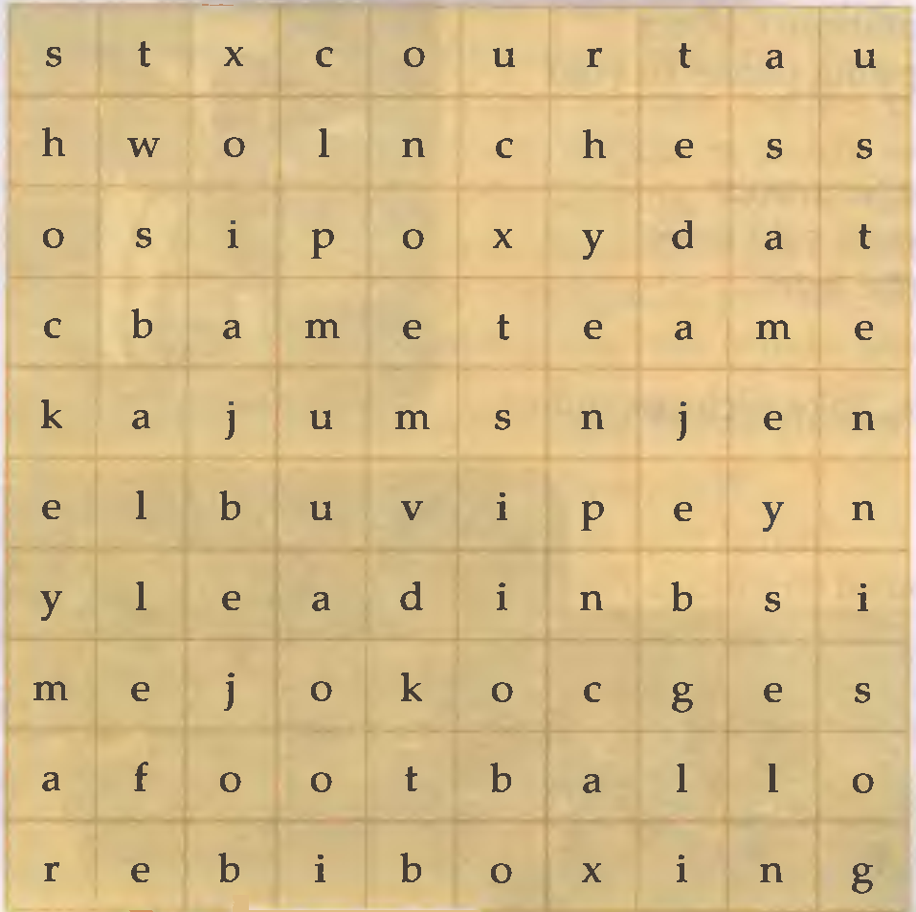Найдите 10 слов. Все слова имеют отношение к спорту (виды спорта, инвентарь, коллектив, место). Первые буквы и их количество даны справа. Слова располагаются слева направо, сверху внизи, по диагонали.

1. S (8 letters)

2. J (4)

3. T (6)

4. C (5)

5. F (8)

6. H (6)

7. B (6)

8. C (5)

9. T (4)

10. B (4)